PRIORITY BOOKING for Incumbent Exhibitors form
The 1st Geopolymers Asia-Pacific Conference 2026
GAPC 2026

December 8-12, 2026

The Empress Chiang Mai Hotel, Chiang Mai, Thailand

Date: ……………………………………………

Company Name or University Name: …………………………………………………………………………………………
Address: …………………………………………………………………………………………….……
…………………………………………………………………………………………………..………
……………………………………………………………Postal code: …………………………………
Tel: ………………………………..………………Fax: ……………………………………
Contact Person: ……………………………………………………………………..………
E-mail: ………………………………………………………………………………………

Mode of Payment:
- Cash
- Cheque payable to Thailand Concrete Association
- Bank Transfer transferred to Thailand Concrete Association
Siam Commercial PCL, Seeyak Sriwara Branch
Account No.: 140-255084-3 (Saving Account)
(Please send a copy of pay-in slip to TCA)

……………………..……………..Signature

(…………………………..………………)
Managing Director or Authorized Person

Sponsor Packages
Zone | Price (USD) | Benefits
Platinum | 3,000 | - 2.7 sq m of exhibition space  - Company logo positioning on conference website  - Company poster at exhibition area  - In case you do not wish to set up a booth. You will receive 2 free registrations
Gold | 2,000 | - 1.35 sq m of exhibition space  - Company logo positioning on conference website  - Company poster at exhibition area  - In case you do not wish to set up a booth. You will receive 1 free registration
Silver | 1,000 | - Company logo positioning on conference website  - Company poster at exhibition area  - Receive 1 free registration
Bronze | 500 | - Company logo positioning on conference website

Booking for Exhibition: Booth No.: .....……………..…………………..

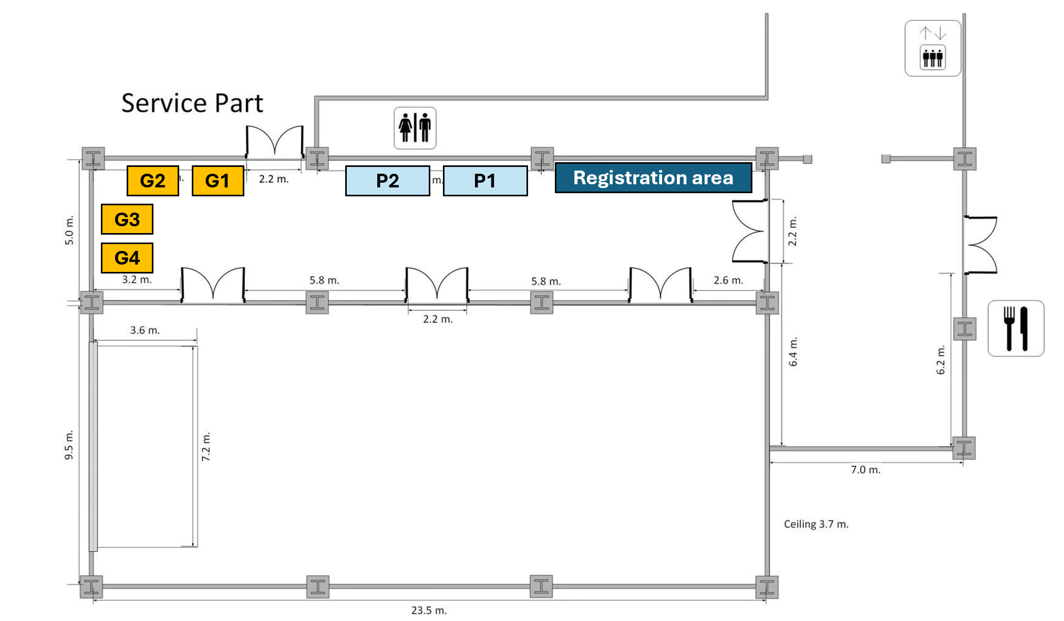

Please send the response form to email : gapc2026.tca@gmail.com

