Type your paper title here
Firstname A. LASTNAME¹, Firstname B. LASTNAME², and Firstname C. LASTNAME^{1,*}
¹University/Institute Mailing Address, Street/Road, City/Province, State, Zip Code, Country
²University/Institute Mailing Address, Street/Road, City/Province, State, Zip Code, Country
*Corresponding author e-mail: example@domain.ac.th, Phone: +xx (0) xxxxxxx,
Fax: +xx (0) xxxxxxx

Abstract
Insert your abstract here covering some short descriptions of motivations, research procedure, results, and conclusions (maximum length 200 words).

Keywords: …………….; …………; ………….; …………. (3-5 keywords)

1. Introduction
2. Experimental
2.1 Subsection
Type your text here.
Equation examples:
y = mx + c (1)
E = mc² (2)
3. Results and discussion (Results section and Discussion section may be separated)
4. Conclusions
5. Acknowledgements

In-text citation example:
‘…..good insulators [8]. Rowell [9] has reported that…..’ and ‘…..examined [10]. Du et al. [11] treated fibres at…...’

References (examples)
[1] B. F. Abu-Sharkh and H. Hamid, "Degradation study of date palm fibre/polypropylene composites in natural and artificial weathering: mechanical and thermal analysis," Polymer Degradation and Stability, vol. 85, pp. 967-973, 2004. (Reference to a journal)
[2] I. M. Daniel and O. Ishai, Engineering mechanics of composite materials. New York: Oxford University Press, Inc., 1994. (Reference to a book)
[3] A. Dufresne, "8 - Cellulose-Based Composites and Nanocomposites," in Handbook of Biopolymers and Biodegradable Plastics, ed Boston: William Andrew Publishing, 2013, pp. 153-169. (Reference to a chapter in an edited book)

Figure captions
Figure 1. ………………………………………….
Figure 2. ………………………………………….

Table captions
Table 1. ………………………………………….
Table 2. ………………………………………….

Figures (examples)

Figure 1.

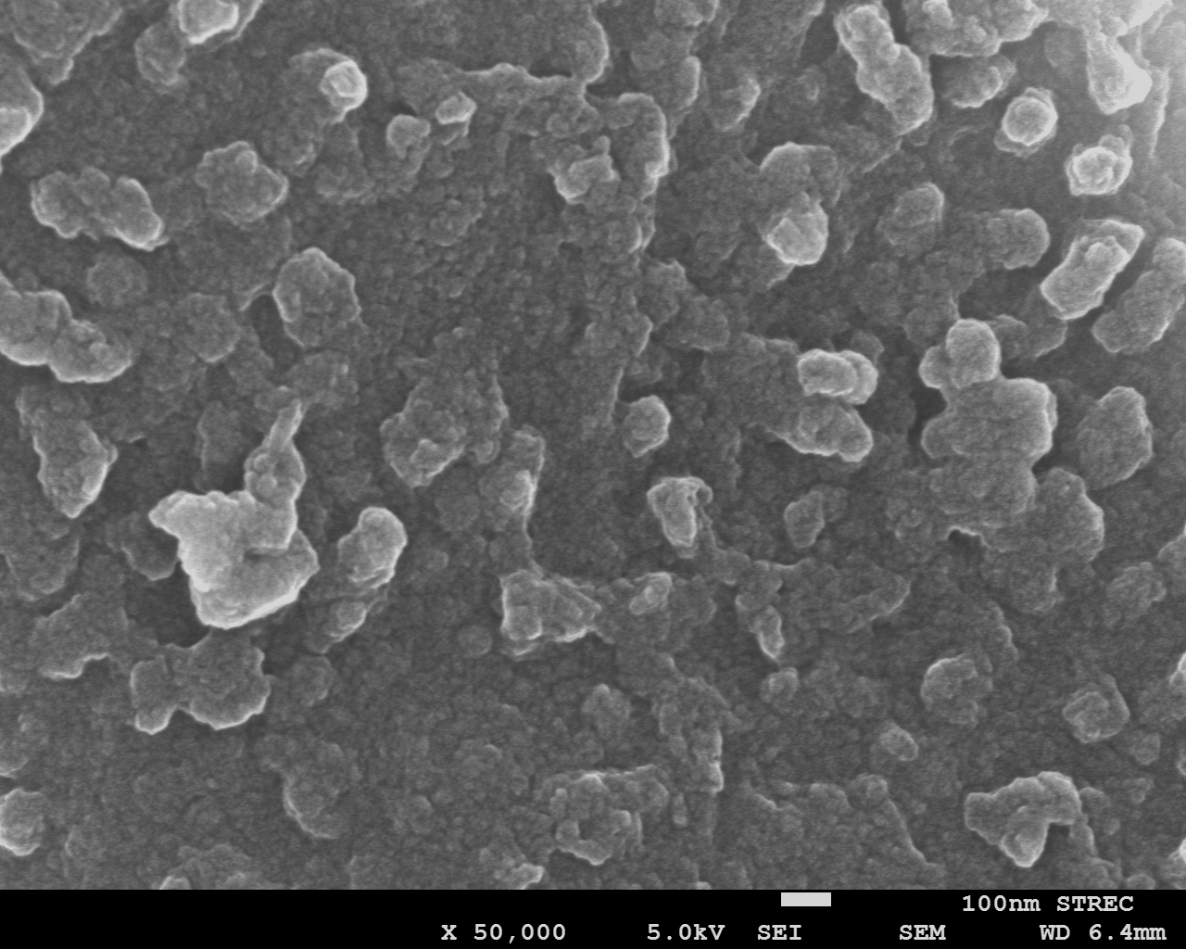
Figure 2.

Tables (examples)
Reinforcement type | Composition (%)
 | A | B | C | D
X | 36 | 15 | 23 | 26
Y | 45 | 28 | 12 | 15
Z | 18 | 49 | 6 | 27

Table 1

Reinforcement type | Crystallinity (%)
X | 78
Y | 59
Z | 83

Table 2

* Total word count for a regular manuscript needs to be between 2,500-6,000
* Total word count for a review manuscript needs to be between 3,000-10,000

For more information, please see JMMM manuscript submission guidelines.

